Question 1)

public class Main {  
 private static int *x*=0;  
 private static int *count*,*count1*=0;  
 public static void main(String[] args) {  
  
 double[][] temperatures = {  
 {36.5, 36.7, 37.1, 36.8, 36.6, 37.0, 36.9},  
 {38.2, 37.8, 38.0, 37.0, 37.5, 38.1, 37.6},  
 {36.4, 36.3, 36.5, 36.2, 36.6, 36.7, 36.8}  
 };  
  
 for(double[] patient:temperatures){  
 for (double daytemp : patient){  
 if(daytemp >=37.5) {  
 //System.out.println(daytemp);  
 *count*++;  
 }else{  
 *count1*++;  
 //System.out.println("Patient " + x + " had no fever");  
 }  
  
  
 }  
 *x*++;  
 // System.out.println(count1);  
 if (*count*==0){  
 System.*out*.println("Patient " + *x* + " had no fever");  
 //continue;  
 }else{  
 System.*out*.println("Patient " + *x* + " had a fever "+*count*+" times");  
 }  
 *count* =0;  
 *count1*=0;  
  
  
 }  
 }  
}

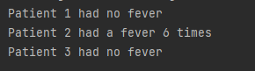

Question 2)

import java.util.Scanner;  
public class q2 {  
 private static int *x* = 0;  
 private static int *count*, *count1* = 0;  
  
 public static void main(String[] args) {  
 Scanner input = new Scanner(System.*in*);  
  
 System.*out*.print("Enter Your Age: ");  
 int age = input.nextInt();  
  
 if (age >= 18) {  
 System.*out*.println("You are eligible to vote.");  
 if (age >= 65) {  
 System.*out*.println("You are also eligible for senior citizen benefits.");  
 } else {  
 System.*out*.println("You are not eligible for senior citizen benefits.");  
 }  
 }else{  
 System.*out*.println("You are not eligible to vote.");  
 }  
  
  
 }  
 }

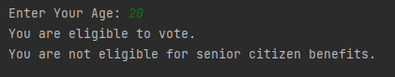

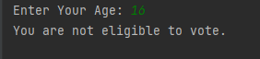

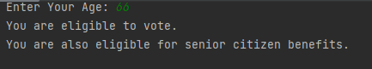

Question 3)

public class q3 {  
 private static int *total* =1;  
 public static void main(String[] args) {  
 int input = 9;  
 int count=1;  
  
 while (input >=count){  
 *total* *=count;  
 count +=1;  
 }  
 System.*out*.println("factorial val of "+input+" is "+*total*);  
  
 *total* =1;  
  
 for(int x=1;x<=input;x++){  
 *total* *=x;  
 }  
 System.*out*.println("factorial val of "+input+" is "+*total*);  
  
 *total* =1;  
 count=1;  
  
 do {  
 *total*\*=count;  
 count++;  
 }while (count!=(input+1));  
  
 System.*out*.println("factorial val of "+input+" is "+*total*);  
 }  
}

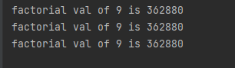

Question 4)

public class q4 {  
 private static int *total* =1;  
 public static void main(String[] args) {  
  
 int size=6;  
  
 for(int i=0;i<size;i++){  
 for(int x=0;x<=i;x++){  
 System.*out*.print("*");  
 }  
 System.*out*.println("");  
 }  
 }  
}

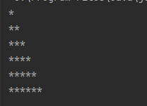

Question 5)

import java.util.Scanner;  
public class q5 {  
 public static void main(String[] args) {  
 Scanner input = new Scanner(System.*in*);  
  
 System.*out*.print("Enter Your no: ");  
 int no = input.nextInt();  
 //int no = 5;  
 int p=no;  
  
 for(int i=p;i>0;i--){  
 for(int x=1;x<=i;x++){  
 System.*out*.print(i);  
 }  
 System.*out*.println("");  
 }  
 }  
}

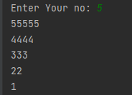

Question 6)

import java.util.Scanner;  
public class q6{  
 private static int *q*=1;  
  
 public static int getTriangleNumber(int n) {  
 return 2*n-1;  
 }  
  
 public static void main(String[] args) {  
 Scanner input = new Scanner(System.*in*);  
  
 System.*out*.print("Enter Your no: ");  
 int no = input.nextInt();  
 String space =" ";  
 String star ="*";  
 int p=no;  
  
 for(int i=*q*;p>=*q*;i++){  
 for(int x=(p-*q*);x>0;x--){  
 System.*out*.print(space);  
 }  
 System.*out*.print(star.repeat(*getTriangleNumber*(i)));  
 System.*out*.println("") ;  
 *q*++;  
 }  
 }  
}

Question 7)

import java.util.Scanner;  
public class q7{  
 private static int *q*=1;  
 public static void main(String[] args) {  
 Scanner input = new Scanner(System.*in*);  
  
 for(int x=1;x<=20;x++){  
 if((x%5==0)){  
 System.*out*.println("Loop terminated.");  
 break;  
 }  
 System.*out*.println(x);  
 }  
 System.*out*.println("");  
 System.*out*.println("--b part--");  
 for(int x=1;x<=20;x++){  
 if((x%2==1)){  
 continue;  
 }  
 System.*out*.println(x);  
 }  
  
 }  
}

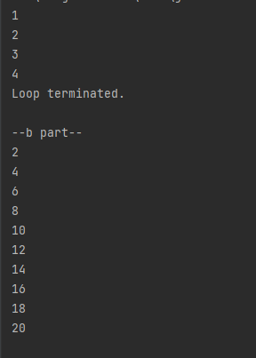

Question 8)

import java.util.Date;  
public class q8{  
 private static int *q*=1;  
 public static void main(String[] args) {  
  
 Date d1 = new Date();  
 if (d1.getHours()<12){  
 System.*out*.println("Morning");  
 } else if (d1.getHours()<18) {  
 System.*out*.println("Day");  
 }else{  
 System.*out*.println("Night");  
 }  
  
  
 }  
}



Question 9)

import java.util.Scanner;  
public class q9{  
 private static int *q*=1;  
 public static void main(String[] args) {  
  
 Scanner input = new Scanner(System.*in*);  
  
 System.*out*.print("Enter the radius of the circle: ");  
 double radius = input.nextDouble();  
  
 double pi =Math.*PI*;  
 double area = pi*Math.*pow*(radius,2);  
 double circumference =2*pi*radius;  
  
 System.*out*.printf("Area: %.2f\n",area);  
 System.*out*.printf("Circumference: %.2f",circumference);  
  
  
  
 }  
}

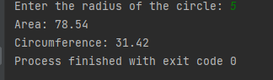

Question 10)

public class q10{  
  
 static void printRange(int x, int y){  
  
 if(x>y){  
 for (int i=x;i>=y;i--) {  
 System.*out*.print(i+" ");  
 }  
 System.out.println(" ");  
 }else {  
 for (int i=x;i<=y;i++) {  
 System.out.print(i+" ");  
 }  
 System.out.println(" ");  
 }  
  
 }  
 public static void main(String args[]){  
 printRange(2,8);  
 printRange(17,10);  
 printRange(5,5);  
  
 }  
}

